“AYH MART: Checkout System”

A PROJECT REPORT
SUBMITTEDBY
HariKrushna (ET25IMCA008)
Aum (ET25IMCA039)
Yesh (ET25IMCA044)

UNDER THE GUIDANCEOF
Prof. Veer Pachchigar

In Fulfillment of subject Software Project[IMCA16212]
Of
IntegratedMasterofComputerApplications
At

SarvajanikCollegeofEngineeringandTechnology,Surat.
SarvajanikUniversity
May,2026

 | SarvajanikEducationSociety  SarvajanikCollegeofEngineering&Technology,Surat.  DepartmentofComputerApplications Academic Year:2025-26 | 

Date:

CERTIFICATE

This is to certify that the project entitled “AYH MART: Checkout System” has been submitted by HariKrushna (ET25IMCA008), Aum (ET25IMCA039), Yesh (ET25IMCA044) towards the fulfillment for the subject Software Project in C/C++ in 2nd Semester of IMCA of Sarvajanik University, Surat during the academic year 2025-2026.

Prof. Veer Pachchigar | Dr. Gayatri Kapadia (Head-Department of Computer  Applications)
(Guide’s Signature)

Examiner’sSignature
1.
2.

ACKNOWLEDGEMENT
We would like to express my sincere and heartfelt gratitude to our respected project guide, Prof. Veer Pachchigar, for his constant guidance, valuable suggestions, and continuous support throughout the development of this project. His knowledge, encouragement, and motivation played a crucial role in successfully completing the AYH Mart: A Self-Checkout Convenience Store Management.

We are also thankful to Sarvajanik College of Engineering & Technology, Surat, for providing us with the opportunity, infrastructure, and learning environment necessary to carry out this project work effectively. The academic curriculum and practical exposure provided by the institution have greatly contributed to the successful implementation of this project.

We would also like to extend my gratitude to all the faculty members of the MCA (Integrated) department for their guidance and for sharing their knowledge, which helped us strengthen our technical skills and understanding of programming concepts such as Object-Oriented Programming and file handling in C.

We are deeply thankful to my team members for their cooperation, teamwork, and dedication throughout the project. Their ideas, efforts, and coordination made this project more efficient and successful.

This project has been a valuable learning experience, allowing us to apply theoretical concepts into practical implementation and enhance our problem solving and development skills.

Group Members:
Harikrushna | ET25IMCA008 | MCA (Integrated)
Aum | ET25IMCA039 | MCA (Integrated)
Yash | ET25IMCA044 | MCA (Integrated)

Mentor: Prof. Veer Pachchigar
Dr.Gayatri Kapadiya
Institution: Sarvajanik College of Engineering and Technology, Surat, India
Program: MCA (Integrated)

Index
Sr.No | Topic | PageNo
1. | Abstract
2. | Objective
3. | SourceCode
4. | Screenshots
5. | Testcases
6. | Conclusion
7. | References

PROJECT ABSTRACT

AYH MART CHECKOUT SYSTEM

AYH Mart is a console-based checkout system developed in C, designed for a retail store. It allows customers to independently browse products, add items to a cart, and complete purchases via Cash or UPI QR Code.

The system supports three user roles - Customer, Staff, and Admin - each with a dedicated portal. Key features include product inventory management, a tiered membership discount program (Silver, Gold, Platinum), customer account management, and a detailed sales reporting module.

All data is managed in-memory using C structures, making the system
lightweight, efficient, and fully functional as a retail management
solution.
Objective

• To develop a console-based retail checkout system using C

• To implement role-based access (Admin, Staff, Customer)

• To design an efficient inventory management system

• To enable customer self-checkout functionality

• To provide multiple payment options (Cash and UPI QR Code)

• To implement a membership system with tiered discounts (Silver, Gold, Platinum)

• To manage customer accounts and purchase records

• To generate sales reports and analytics

• To build a simple, fast, and user-friendly system using modular programming

1. C-Based System
Create a system using C programming
language

2. Implement user roles for customers
and staff
Role-based Access

3. Streamline inventory tracking and
management processes Inventory Management

Source Code
1] ------------------ MAIN ------------------
int main() {
shop[0] = (struct Product){101, "Rice", 45.00, 80, "Grocery"};
shop[1] = (struct Product){102, "Milk", 25.00, 120, "Dairy"};
shop[2] = (struct Product){103, "Bread", 30.00, 60, "Bakery"};
shop[3] = (struct Product){104, "Shampoo", 90.00, 40, "Personal"};
shop[4] = (struct Product){105, "PenDrive", 350.00, 15, "Electronics"};
nProducts = 5;

customers[0] = (struct Customer){1, "aum", "123", "9876543210", "aum@email.com", 0};
customers[1] = (struct Customer){2, "hari", "123", "9876543211", "hari@email.com", 0};
customers[2] = (struct Customer){3, "yash", "123", "9876543212", "yash@email.com", 0};
nCustomers = 3;

loadAllData();
mainManu();
return 0;
}

2] ------------------ MAIN MENU ------------------
void mainManu() {
int choice;
while (1) {
system("cls");
printHeader("AYH MART | Surat, India");
printHeader("WELCOME");
printf(" 1. Customer Self-Checkout\n");
printf(" 2. Staff / Admin Login\n");
printf(" 3. View Store Info\n");
printf(" 0. Exit Application\n");
printDash();
printf(" Enter your choice: ");

if (!readInt(&choice)) {
WARN("Invalid input. Try again.");
system("pause");
continue;
}

switch (choice) {
case 1: cust(); break;
case 2: login(); break;
case 3: info(); break;
case 0:
printHeader("Thank you for visiting AYH Mart!");
exit(0);
default:
WARN("Invalid option. Try again.");
system("pause");
}
}
}
3] ------------------ LOGIN ------------------
void login() {
char username[20], password[20];
system("cls");
printHeader("AYH MART | Surat, India");
printHeader("STAFF / ADMIN LOGIN");
printf(" Username: ");
scanf("%19s", username);
printf(" Password: ");
inputPassword(password);

if (strcmp(username, ad_user) == 0 && strcmp(password, ad_pass) == 0) {
printf("\n");
OK("Logged in as ADMIN");
system("pause");
adminDashboard();
} else if (strcmp(username, sf_user) == 0 && strcmp(password, sf_pass) == 0) {
printf("\n");
OK("Logged in as STAFF");
system("pause");
staff();
} else {
printf("\n");
ERR("Incorrect username or password.");
system("pause");
}
}

4] ------------------ ADMIN DASHBOARD ------------------
void adminDashboard() {
int choice;
while (1) {
system("cls");
printHeader("AYH MART | Surat, India");
printHeader("ADMIN PORTAL");
printf(" 1. Inventory\n");
printf(" 2. Members\n");
printf(" 3. Sales Report\n");
printf(" 4. Customer Accounts\n");
printf(" 5. Backup & Restore Data\n");
printf(" 0. Logout\n");
printDash();
printf(" Enter your choice: ");

if (!readInt(&choice)) {
WARN("Invalid input.");
system("pause");
continue;
}

switch (choice) {
case 1: inventory(); break;
case 2: members(); break;
case 3: salesManu(); break;
case 4: custManage(); break;
case 5: backupRestore(); break;
case 0:
printf("\n");
OK("Logged out successfully.");
printf("\n");
system("pause");
return;
default:
WARN("Invalid option.");
system("pause");
}
}
}

5] ------------------ INVENTORY ------------------
void inventory() {
int choice;
while (1) {
system("cls");
printHeader("AYH MART | Surat, India");
printHeader("INVENTORY MANAGEMENT");
printf(" 1. Add Product(s)\n");
printf(" 2. Edit Product\n");
printf(" 3. Delete Product\n");
printf(" 4. View All Products\n");
printf(" 0. Back\n");
printDash();
printf(" Enter your choice: ");

if (!readInt(&choice)) {
WARN("Invalid input.");
system("pause");
continue;
}

switch (choice) {
case 1: add(); break;
case 2: editProduct(); break;
case 3: del(); break;
case 4: view(); break;
case 0: return;
default:
WARN("Invalid option.");
system("pause");
}
}
}

6] ------------------ STORE INFO ------------------
void info() {
system("cls");
printHeader("AYH MART | Surat, India");
printHeader("STORE INFORMATION");
printf(" Store Name : AYH Mart\n");
printf(" Location : Surat, India\n");
printf(" Timing : 9 AM - 10 PM (Mon-Sun)\n");
printf(" Developed By : Aum, Yesh, HariKrushna\n");
printLine();
system("pause");
}

7] ------------------ CUSTOMER LOGIN ------------------
int customerLogin() {
int id, i;
char pass[20];
system("cls");
printHeader("AYH MART | Surat, India");
printHeader("CUSTOMER LOGIN");
printf(" Customer ID : ");
if (!readInt(&id)) {
printf("\n");
ERR("Invalid ID.");
system("pause");
return -1;
}
printf(" Password : ");
inputPassword(pass);

for (i = 0; i < nCustomers; i++) {
if (customers[i].cId == id && strcmp(customers[i].cPass, pass) == 0) {
printf("\n");
printf(" [OK] Welcome, %s!\n", customers[i].cName);
system("pause");
custLoggedIn = 1;
currentCustIdx = i;
return i;
}
}
printf("\n");
ERR("Invalid Customer ID or Password.");
system("pause");
return -1;
}

8] ------------------ CUSTOMER MENU ------------------
void cust() {
int choice, i;

if (!custLoggedIn) {
if (customerLogin() == -1) return;
}

while (1) {
system("cls");
printHeader("AYH MART | Surat, India");
printHeader("CUSTOMER SELF-CHECKOUT");
printf(" Welcome, %s\n", customers[currentCustIdx].cName);
printDash();
printf(" 1. View Store Products\n");
printf(" 2. Search for a Product\n");
printf(" 3. Add Item to Basket\n");
printf(" 4. View My Basket\n");
printf(" 5. Final Checkout\n");
printf(" 6. My Membership Card\n");
printf(" 0. Logout & Return to Main Menu\n");
printDash();
printf(" Enter your choice: ");

if (!readInt(&choice)) {
WARN("Invalid input.");
system("pause");
continue;
}

switch (choice) {
case 1: custView(); break;
case 2: search(); break;
case 3:
system("cls");
printHeader("AYH MART | Surat, India");
printHeader("ADD ITEM TO BASKET");
if (nProducts == 0) {
WARN("No products available.");
} else {
printf(" %-6s %-18s %-8s %-6s %s\n", "CODE", "NAME", "PRICE", "STOCK", "CATEGORY");
printDash();
for (i = 0; i < nProducts; i++) {
printf(" %-6d %-18s %-8.2f %-6d %s\n",
shop[i].pCode, shop[i].pName, shop[i].pPrice,
shop[i].pStock, shop[i].pCategory);
}
}
addCart();
break;
case 4: viewCart(); break;
case 5: checkout(); return;
case 6: viewMyCard(); break;
case 0:
custLoggedIn = 0;
currentCustIdx = -1;
return;
default:
WARN("Invalid option.");
system("pause");
}
}
}

9] ------------------ STORE INFO ------------------
void info() {
system("cls");
printHeader("AYH MART | Surat, India");
printHeader("STORE INFORMATION");
printf(" Store Name : AYH Mart\n");
printf(" Location : Surat, India\n");
printf(" Timing : 9 AM - 10 PM (Mon-Sun)\n");
printf(" Developed By : Aum, Yesh, HariKrushna\n");
printLine();
system("pause");
}

9] ------------------ CUSTOMER LOGIN ------------------
int customerLogin() {
int id, i;
char pass[20];
system("cls");
printHeader("AYH MART | Surat, India");
printHeader("CUSTOMER LOGIN");
printf(" Customer ID : ");
if (!readInt(&id)) {
printf("\n");
ERR("Invalid ID.");
system("pause");
return -1;
}
printf(" Password : ");
inputPassword(pass);

for (i = 0; i < nCustomers; i++) {
if (customers[i].cId == id && strcmp(customers[i].cPass, pass) == 0) {
printf("\n");
printf(" [OK] Welcome, %s!\n", customers[i].cName);
system("pause");
custLoggedIn = 1;
currentCustIdx = i;
return i;
}
}
printf("\n");
ERR("Invalid Customer ID or Password.");
system("pause");
return -1;
}

10] ------------------ CUSTOMER MENU ------------------
void cust() {
int choice, i;

if (!custLoggedIn) {
if (customerLogin() == -1) return;
}

while (1) {
system("cls");
printHeader("AYH MART | Surat, India");
printHeader("CUSTOMER SELF-CHECKOUT");
printf(" Welcome, %s\n", customers[currentCustIdx].cName);
printDash();
printf(" 1. View Store Products\n");
printf(" 2. Search for a Product\n");
printf(" 3. Add Item to Basket\n");
printf(" 4. View My Basket\n");
printf(" 5. Final Checkout\n");
printf(" 6. My Membership Card\n");
printf(" 0. Logout & Return to Main Menu\n");
printDash();
printf(" Enter your choice: ");

if (!readInt(&choice)) {
WARN("Invalid input.");
system("pause");
continue;
}

switch (choice) {
case 1: custView(); break;
case 2: search(); break;
case 3:
system("cls");
printHeader("AYH MART | Surat, India");
printHeader("ADD ITEM TO BASKET");
if (nProducts == 0) {
WARN("No products available.");
} else {
printf(" %-6s %-18s %-8s %-6s %s\n", "CODE", "NAME", "PRICE", "STOCK", "CATEGORY");
printDash();
for (i = 0; i < nProducts; i++) {
printf(" %-6d %-18s %-8.2f %-6d %s\n",
shop[i].pCode, shop[i].pName, shop[i].pPrice,
shop[i].pStock, shop[i].pCategory);
}
}
addCart();
break;
case 4: viewCart(); break;
case 5: checkout(); return;
case 6: viewMyCard(); break;
case 0:
custLoggedIn = 0;
currentCustIdx = -1;
return;
default:
WARN("Invalid option.");
system("pause");
}
}
}

11] ------------------ Checkout ------------------
void checkout() {
int mid, i, payChoice;
float subtotal = 0, discount = 0, finalAmount;
system("cls");
printHeader("AYH MART | Surat, India");
printHeader("CHECKOUT");
if (cartCount == 0) {
WARN("Basket is empty.");
system("pause");
return;
}

for (i = 0; i < cartCount; i++) subtotal += cart[i].price * cart[i].qty;

printf("\n Enter Member ID (0 if none): ");
if (!readInt(&mid)) mid = 0;

discount = applyDiscount(mid, subtotal);
finalAmount = subtotal - discount;

printDash();
printf(" Subtotal : %.2f\n", subtotal);
printf(" Discount : %.2f\n", discount);
printf(" Payable Amount : %.2f\n", finalAmount);
printDash();

printf("\n SELECT PAYMENT METHOD:\n");
printf(" 1. Cash\n");
printf(" 2. QR Code (Digital)\n");
printf(" Enter choice: ");
if (!readInt(&payChoice)) payChoice = 1;

for (i = 0; i < cartCount; i++) {
recordSale(cart[i].code, cart[i].name, cart[i].qty, cart[i].price, customers[currentCustIdx].cId);
}

totalBills++;
cartCount = 0;
custLoggedIn = 0;
currentCustIdx = -1;
saveAllData();

if (payChoice == 2) {
printf("\n [ SCAN QR CODE TO PAY - Dhameliya Yash Mukeshbhai ]\n\n");
printQRCode();
printf("\n UPI ID : 6353999107@ptyes\n");
printf(" Amount : Rs. %.2f\n\n", finalAmount);
totalQRPayments++;
saveCounters();
billing(finalAmount, 1);
} else {
totalCashPayments++;
saveCounters();
billing(finalAmount, 0);
}
}

12] ------------------ CUSTOMER ACCOUNT MANAGEMENT ------------------
void custManage() {
int choice;
while (1) {
system("cls");
printHeader("AYH MART | Surat, India");
printHeader("CUSTOMER ACCOUNT MANAGEMENT");
printf(" 1. Add New Customer Account\n");
printf(" 2. Delete Customer Account\n");
printf(" 3. View All Customer Accounts\n");
printf(" 0. Back\n");
printDash();
printf(" Enter your choice: ");

if (!readInt(&choice)) {
WARN("Invalid input.");
system("pause");
continue;
}

switch (choice) {
case 1: addCustomer(); break;
case 2: deleteCustomer(); break;
case 3: viewCustomers(); break;
case 0: return;
default:
WARN("Invalid option.");
system("pause");
}
}
}

13] ------------------ STAFF PORTAL ------------------
void staff() {
int choice;
while (1) {
system("cls");
printHeader("AYH MART | Surat, India");
printHeader("STAFF PORTAL");
printf(" 1. View Inventory\n");
printf(" 2. View All Members\n");
printf(" 3. Add New Member\n");
printf(" 4. Remove Member\n");
printf(" 5. View Sales Summary\n");
printf(" 6. Search Product\n");
printf(" 7. Customer Accounts\n");
printf(" 0. Logout\n");
printDash();
printf(" Enter your choice: ");

if (!readInt(&choice)) {
WARN("Invalid input.");
system("pause");
continue;
}

switch (choice) {
case 1: {
int i;
system("cls");
printHeader("AYH MART | Surat, India");
printHeader("INVENTORY (Staff View)");
if (nProducts == 0) {
WARN("No products.");
} else {
printf(" %-6s %-18s %-8s %-6s %s\n", "CODE", "NAME", "PRICE", "STOCK", "CATEGORY");
printDash();
for (i = 0; i < nProducts; i++)
printf(" %-6d %-18s %-8.2f %-6d %s\n",
shop[i].pCode, shop[i].pName, shop[i].pPrice,
shop[i].pStock, shop[i].pCategory);
}
printf("\n"); system("pause"); break;
}
case 2: {
int i;
system("cls");
printHeader("AYH MART | Surat, India");
printHeader("ALL MEMBERS (Staff View)");
if (nMembers == 0) {
WARN("No members registered.");
} else {
printf(" %-5s %-18s %-10s %-10s %-9s %s\n",
"ID", "NAME", "SPENT", "TIER", "DISCOUNT", "CARD STATUS");
printDash();
for (i = 0; i < nMembers; i++)
printf(" %-5d %-18s %-10.2f %-10s %-9.0f%% %s\n",
Members[i].mId, Members[i].mName, Members[i].mSpent,
Members[i].mTier, Members[i].mDisc,
Members[i].mUsed ? "Used" : "Active");
}
printf("\n"); system("pause"); break;
}
case 3: addMembers(); break;
case 4: deleteMembers(); break;
case 5: staffSalesSummary(); break;
case 6: {
int code, found = 0, i;
system("cls");
printHeader("AYH MART | Surat, India");
printHeader("SEARCH PRODUCT");
printf("\n Enter Product Code to Search: ");
if (!readInt(&code)) {
WARN("Invalid code.");
system("pause");
break;
}
for (i = 0; i < nProducts; i++) {
if (shop[i].pCode == code) {
printDash();
printf(" Found:\n");
printf(" Product Name : %s\n", shop[i].pName);
printf(" Product Price : %.2f\n", shop[i].pPrice);
printf(" Product Stock : %d\n", shop[i].pStock);
printf(" Product Category : %s\n", shop[i].pCategory);
printDash();
found = 1;
break;
}
}
if (!found) ERR("Product not found.");
printf("\n"); system("pause"); break;
}
case 7: {
int staffChoice;
while (1) {
system("cls");
printHeader("AYH MART | Surat, India");
printHeader("CUSTOMER ACCOUNT MANAGEMENT");
printf(" 1. Add New Customer Account\n");
printf(" 2. Delete Customer Account\n");
printf(" 3. View All Customer Accounts\n");
printf(" 0. Back\n");
printDash();
printf(" Enter your choice: ");

if (!readInt(&staffChoice)) {
WARN("Invalid input.");
system("pause");
continue;
}

switch (staffChoice) {
case 1: addCustomer(); break;
case 2: deleteCustomer(); break;
case 3: viewCustomers(); break;
case 0: goto staffCustomerDone;
default:
WARN("Invalid option.");
system("pause");
}
}
staffCustomerDone:;
break;
}
case 0:
OK("Logged out.");
system("pause");
return;
default:
WARN("Invalid option.");
system("pause");
}
}
}

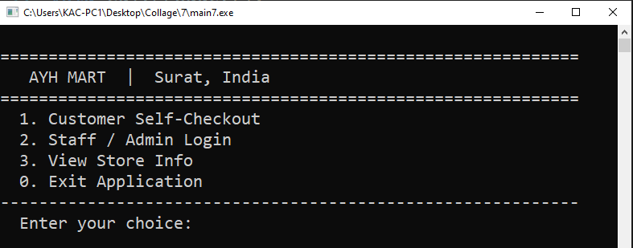
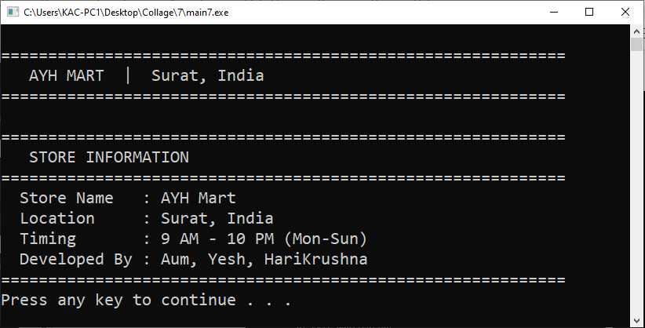
Screenshot

- Main menu

2. View Store Info

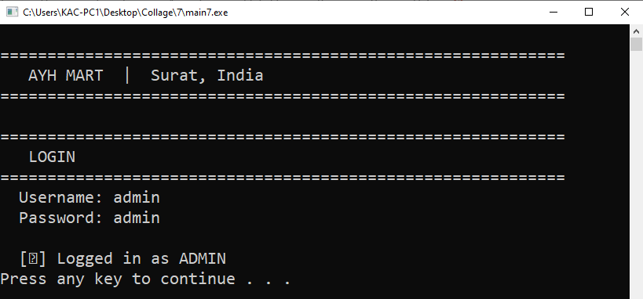
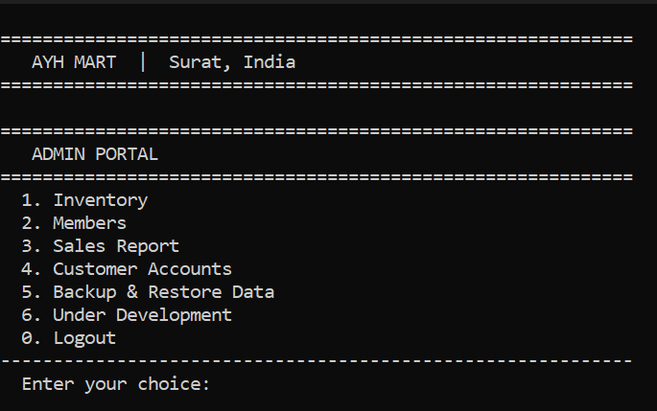

3. Admin Login

4. Admin Portal

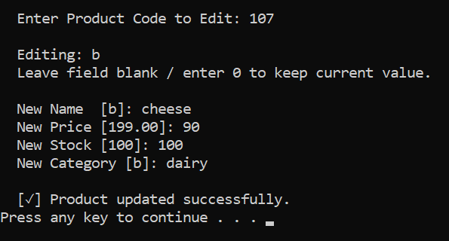
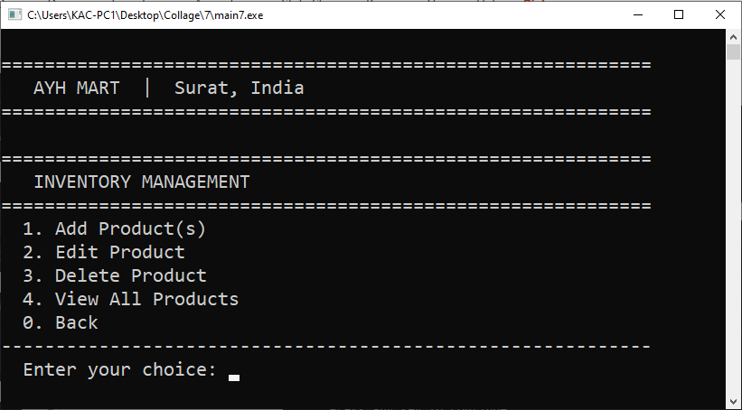
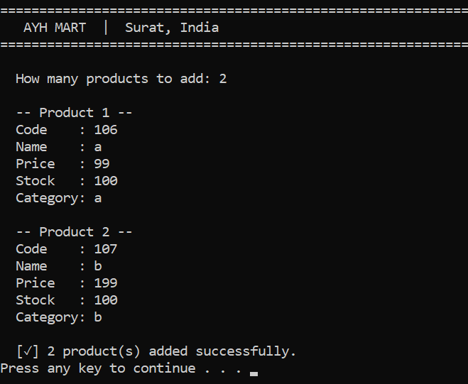
5. Inventory Management

6. Add Product(s)

7. Edit Product

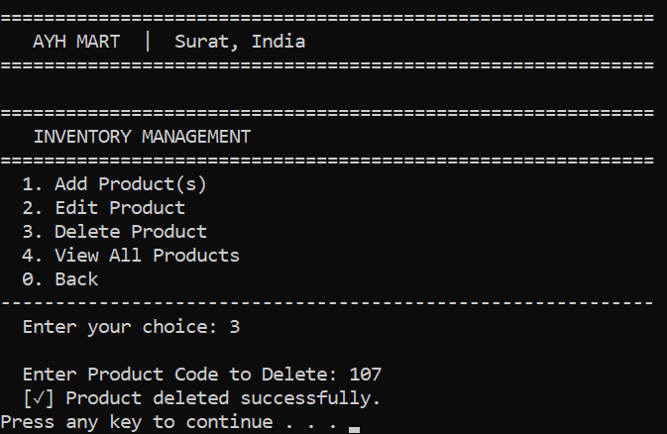
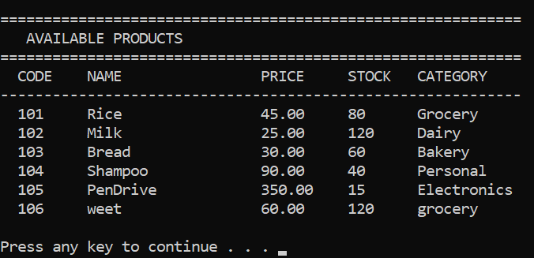

8. Delete Product

9. View all Product

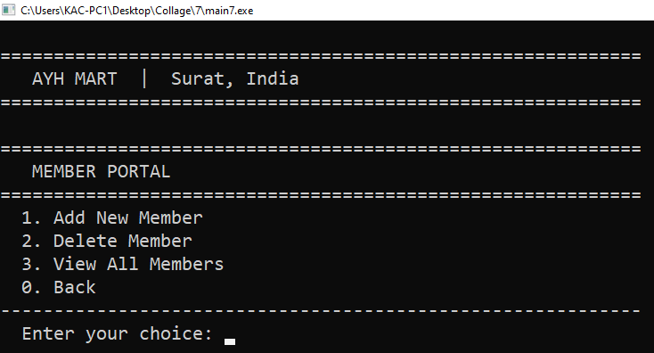
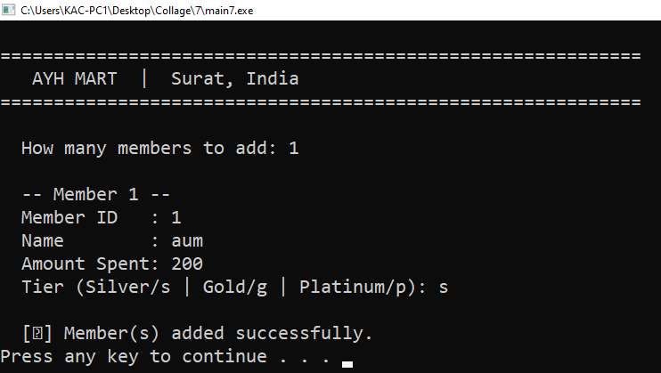

10. Member Portal

11. Add New Member

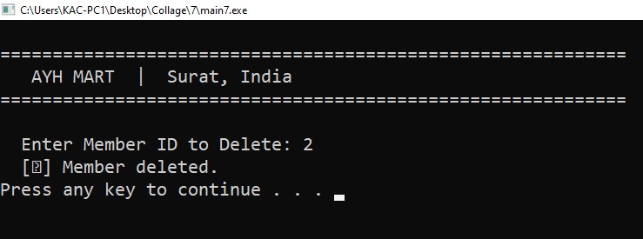
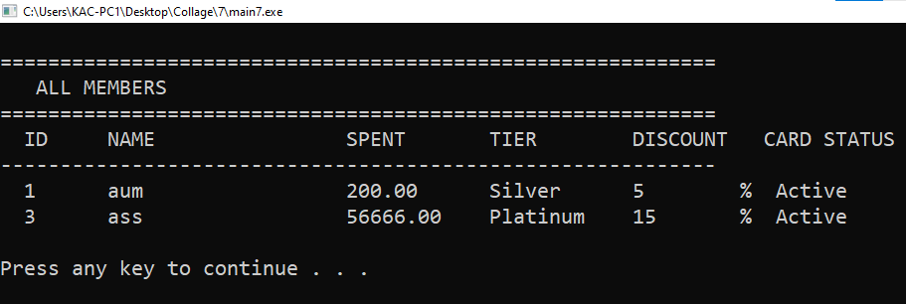

12. Delete Member

13. View all Member

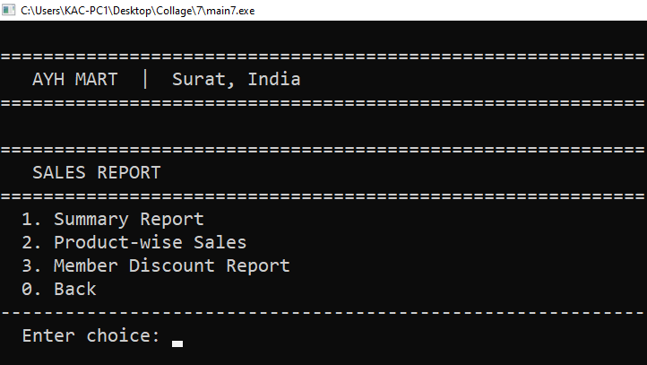

14. Sales Report

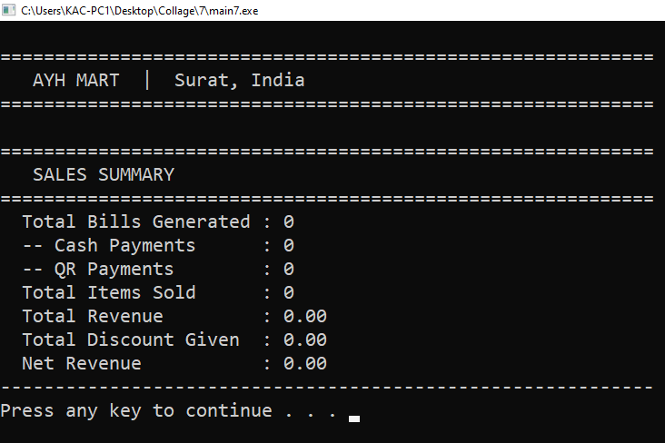

15. Sale Summary

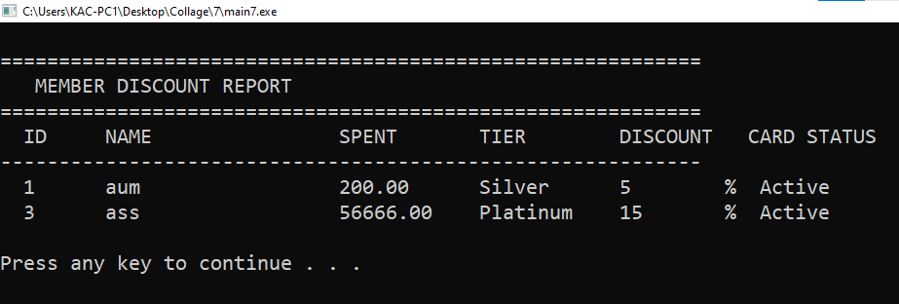
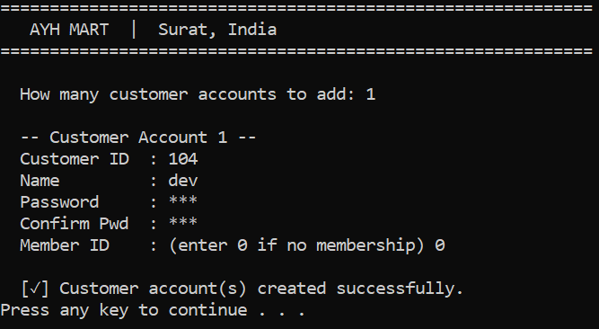
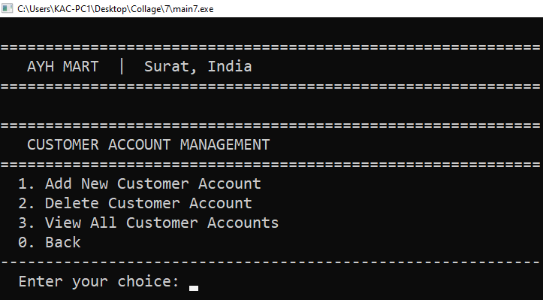
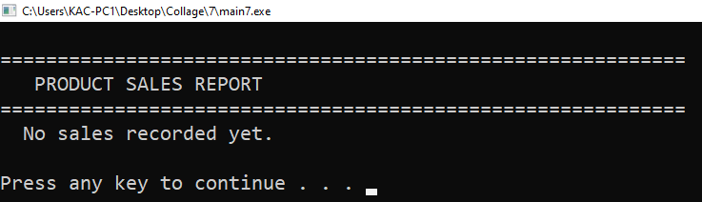
17. Member Discount Report
16. Product Sales Report
19. Add New Customer Account

18. Customer Account Management
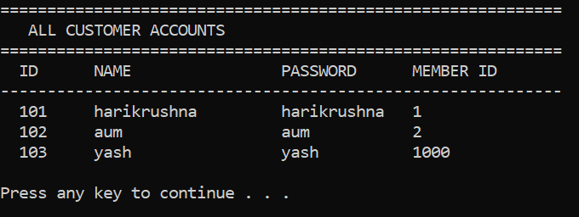
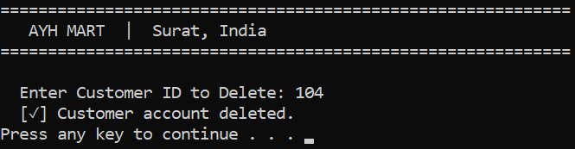
20. View all Customer

21. Delete Customer

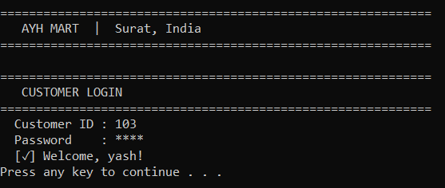
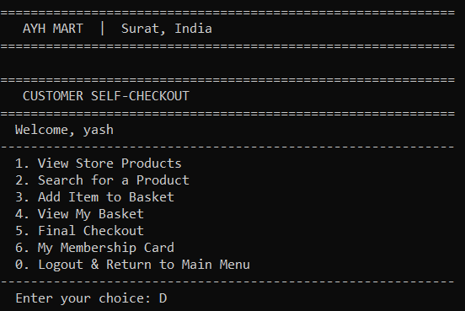

23. Customer Login

24. Customer Portal

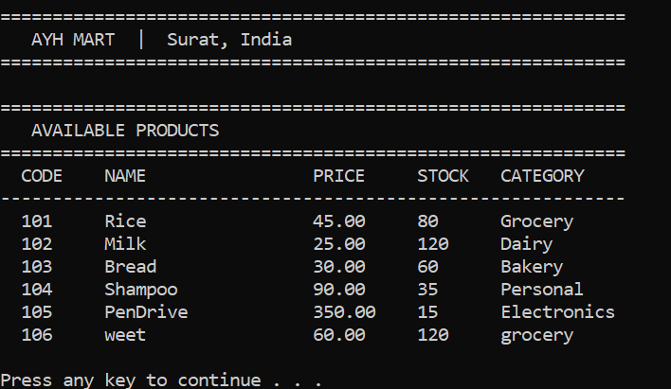
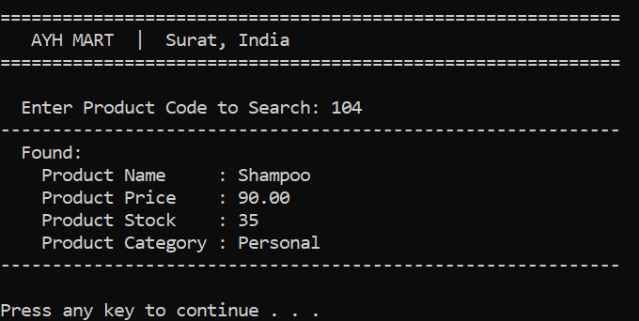

25. View Product

26. Search Product

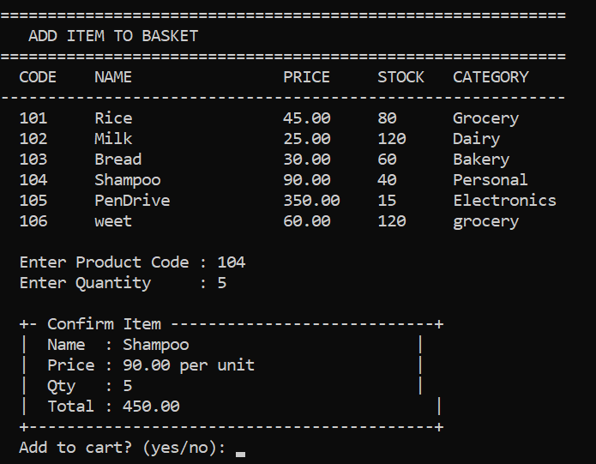
27. Add Item To Basket

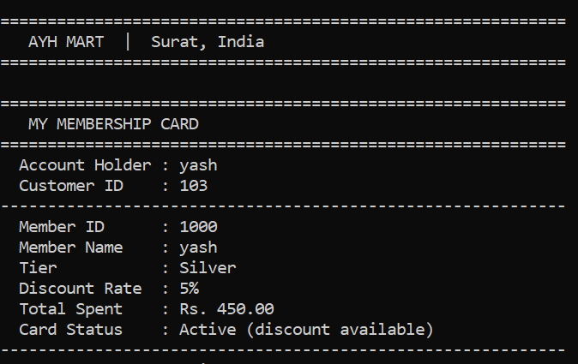
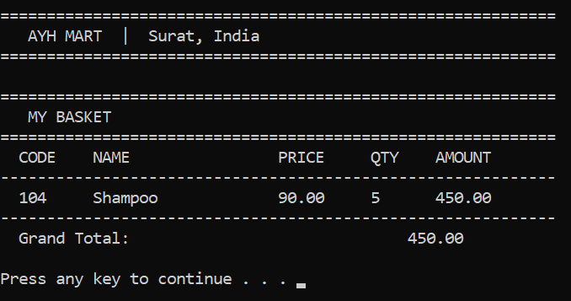
28. View Basket

29. View Membership Card

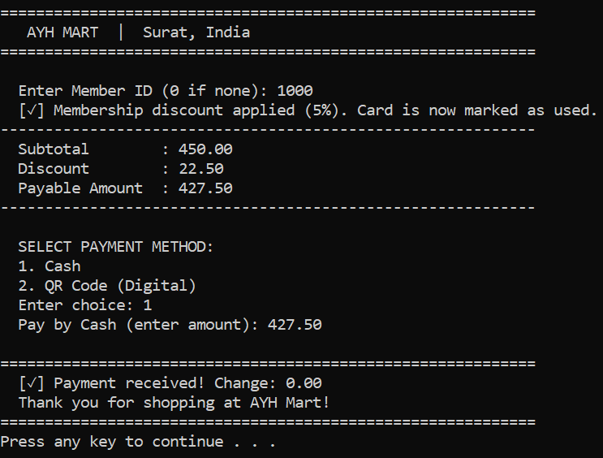
30. Check-Out via cash

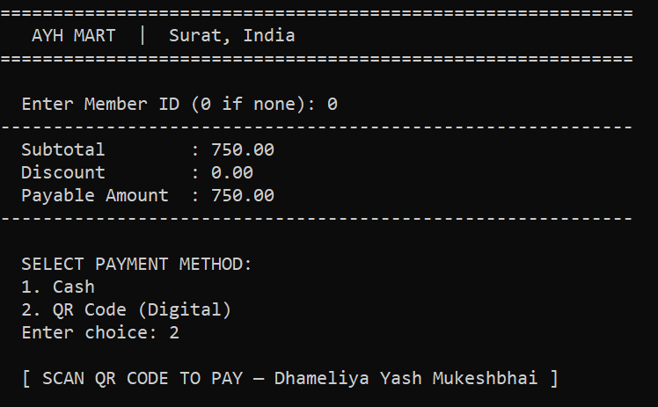
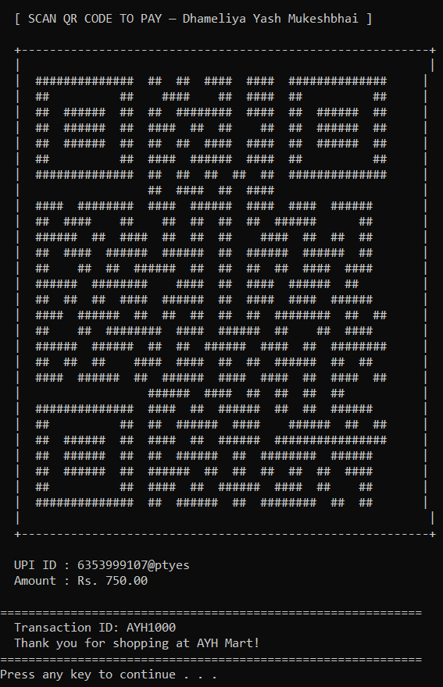

31. Check-Out via QR

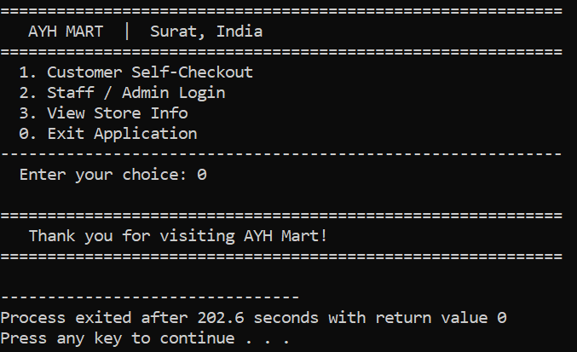
32. Exit Application
Test Cases

1. AUTHENTICATION TEST CASES

TC ID | Scenario | Input | Expected Output | Result
TC01 | Admin login valid | admin / admin | Admin dashboard opens | Pass
TC02 | Staff login valid | staff / staff | Staff portal opens | Pass
TC03 | Login invalid | Wrong credentials | Error message shown | Pass
TC04 | Empty login | Blank input | Error / retry | Pass
TC05 | Case sensitivity | Admin/Admin | Login fail | Pass
TC06 | Password masking | Enter password | Hidden input (*) | Pass

2. CUSTOMER LOGIN

TC ID | Scenario | Input | Expected Output | Result
TC07 | Valid customer login | Correct ID + pass | Welcome message | Pass
TC08 | Invalid login | Wrong ID/pass | Error message | Pass
TC09 | No customers exist | Login attempt | Fail safely | Pass

3. INVENTORY MANAGEMENT

TC ID | Scenario | Input | Expected Output | Result
TC11 | Add product | Valid data | Product added | Pass
TC12 | Add product overflow | >100 items | Limit warning | Pass
TC13 | Edit product | Valid code | Updated product | Pass
TC14 | Edit invalid product | Wrong code | Not found | Pass
TC15 | Delete product | Valid code | Product removed | Pass
TC16 | View products | — | Product list shown | Pass
TC17 | Duplicate product code | Same code | Error message | Pass
TC18 | Delete invalid product | Wrong code | Error message | Pass

4. MEMBER MANAGEMENT

TC ID | Scenario | Input | Expected Output | Result
TC19 | Add member | Valid input | Member created | Pass
TC20 | Invalid tier | Wrong input | Retry prompt | Pass
TC21 | Duplicate membership | Same customer | Error shown | Pass
TC22 | Delete member | Valid ID | Member removed | Pass
TC23 | Delete invalid member | Wrong ID | Error message | Pass
TC24 | View members | — | Member list shown | Pass

5. CUSTOMER ACCOUNT MANAGEMENT

TC ID | Scenario | Input | Expected Output | Result
TC25 | Add customer | Valid data | Account created | Pass
TC26 | Duplicate customer ID | Same ID | Error message | Pass
TC27 | Password mismatch | Wrong confirm | Retry | Pass
TC28 | Delete customer | Valid ID | Account removed | Pass
TC29 | Delete invalid customer | Wrong ID | Error message | Pass
TC30 | View customers | — | List shown | Pass

6. PRODUCT SEARCH & VIEW

TC ID | Scenario | Input | Expected Output | Result
TC31 | Search valid product | Existing code | Product details | Pass
TC32 | Search invalid product | Wrong code | Not found message | Pass
TC33 | View all products | — | Display list | Pass

7. CART OPERATIONS

TC ID | Scenario | Input | Expected Output | Result
TC34 | Add to cart valid | Code + qty | Item added | Pass
TC35 | Insufficient stock | qty > stock | Error shown | Pass
TC36 | Invalid product | Wrong code | Not available | Pass
TC37 | Cart overflow | >50 items | Cart full message | Pass
TC38 | Add item cancel | "no" | Not added | Pass
TC39 | View empty cart | — | Basket empty | Pass

8. CHECKOUT & PAYMENT

TC ID | Scenario | Input | Expected Output | Result
TC40 | Checkout empty cart | — | Warning message | Pass
TC41 | Checkout with items | Valid | Bill generated | Pass
TC42 | Cash exact payment | Exact amount | Success | Pass
TC43 | Cash extra payment | > amount | Change returned | Pass
TC44 | Cash insufficient | < amount | Retry payment | Pass
TC45 | QR payment | Select QR | QR displayed + success | Pass

9. MEMBERSHIP DISCOUNT

TC ID | Scenario | Input | Expected Output | Result
TC46 | Valid member discount | Active ID | Discount applied | Pass
TC47 | Used membership | Same ID again | No discount | Pass
TC48 | Invalid member ID | Wrong ID | No discount | Pass
TC49 | No membership | ID = 0 | No discount | Pass

10. SALES REPORT

TC ID | Scenario | Input | Expected Output | Result
TC50 | Sales summary | — | Stats shown | Pass
TC51 | Product sales | — | Sales list | Pass
TC52 | Discount report | — | Member report | Pass
TC53 | No sales yet | — | Empty message | Pass

11. FILE HANDLING / BACKUP
TC ID | Scenario | Input | Expected Output | Result
TC54 | Save data | Backup option | Files saved | Pass
TC55 | Load data | Restore option | Data loaded | Pass
TC56 | Restore cancel | Select NO | Operation cancelled | Pass
TC57 | Missing files | No file present | Default data loaded | Pass

12. EDGE / STRESS CASES

TC ID | Scenario | Input | Expected Output | Result
TC58 | Negative quantity | -5 | Reject input | Pass
TC59 | Large input strings | Long name | No crash | Pass
TC60 | Rapid operations | Fast inputs | Stable system | Pass
TC61 | Max limits reached | Full data | Warning shown | Pass

REFERENCES

Go Frugal Experience simplicity
https://www.gofrugal.com/retail/?ref=common-header
ZOHO Inventory
https://www.zoho.com/in/inventory/features/

Costco Wholesale
OFFLINE STORE

